**Power BI Assignment 01**

**You are provided with a dataset containing Coffee Sales data. You aim to transform, clean the data, and create a data model.**

**Import Data**

**● Load the provided Coffee Shop Sales into Power BI.**

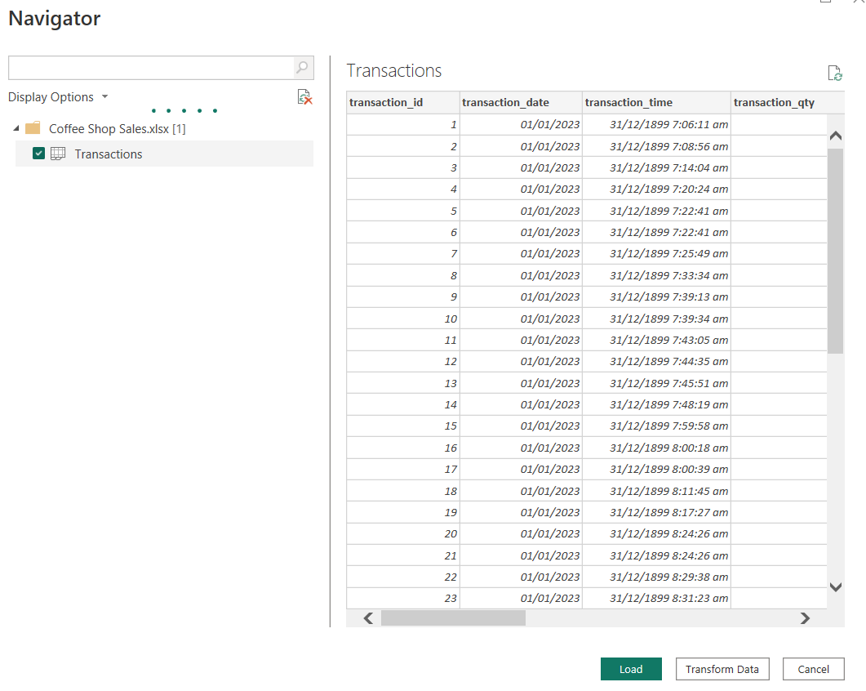

**Data Transformation:**

* **Check Column names, data types, missing, and error values.**

**{Column names, data types}**

{"transaction_id", Int64.Type},

{"transaction_date", type date},

{"transaction_time", type datetime},

{"transaction_qty", Int64.Type},

{"store_id", Int64.Type},

{"store_location", type text},

{"product_id", Int64.Type},

{"unit_price", type number},

{"product_category", type text},

{"product_type", type text},

{"product_detail", type text}

**Missing values:** 0

**Error-values**: 0

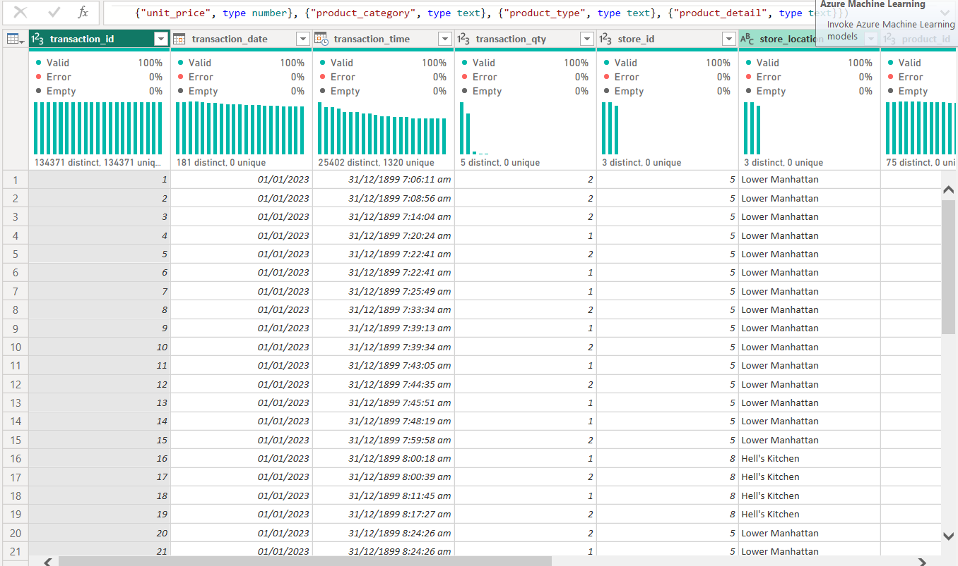

* **Split the dataset into smaller tables to normalize the data:**

**○ Transactions:** transaction_id, transaction_date, transaction_time, transaction_qty, store_id, product_id.

**○ Stores:** store_id, store_location.

**○ Products:** product_id, unit_price, product_category, product_type, product_detail.

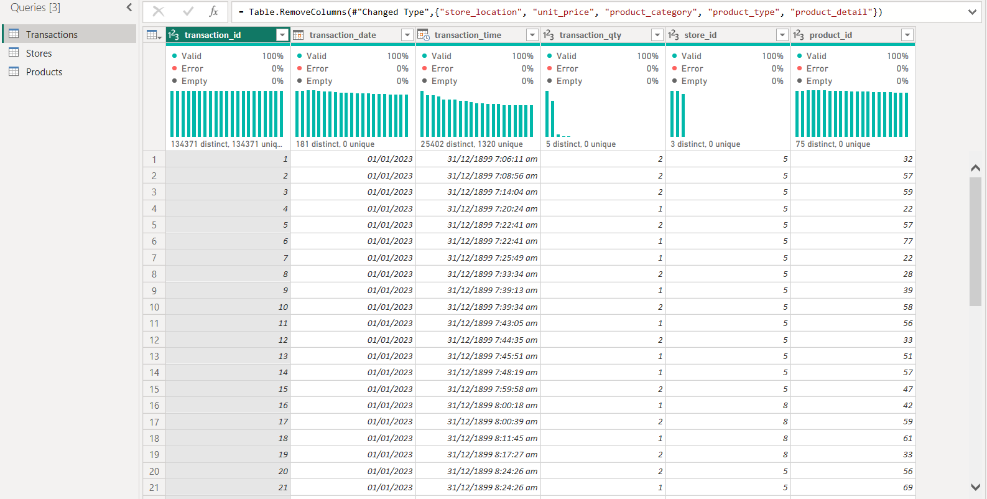

* **Make sure to remove duplicates from each table.**

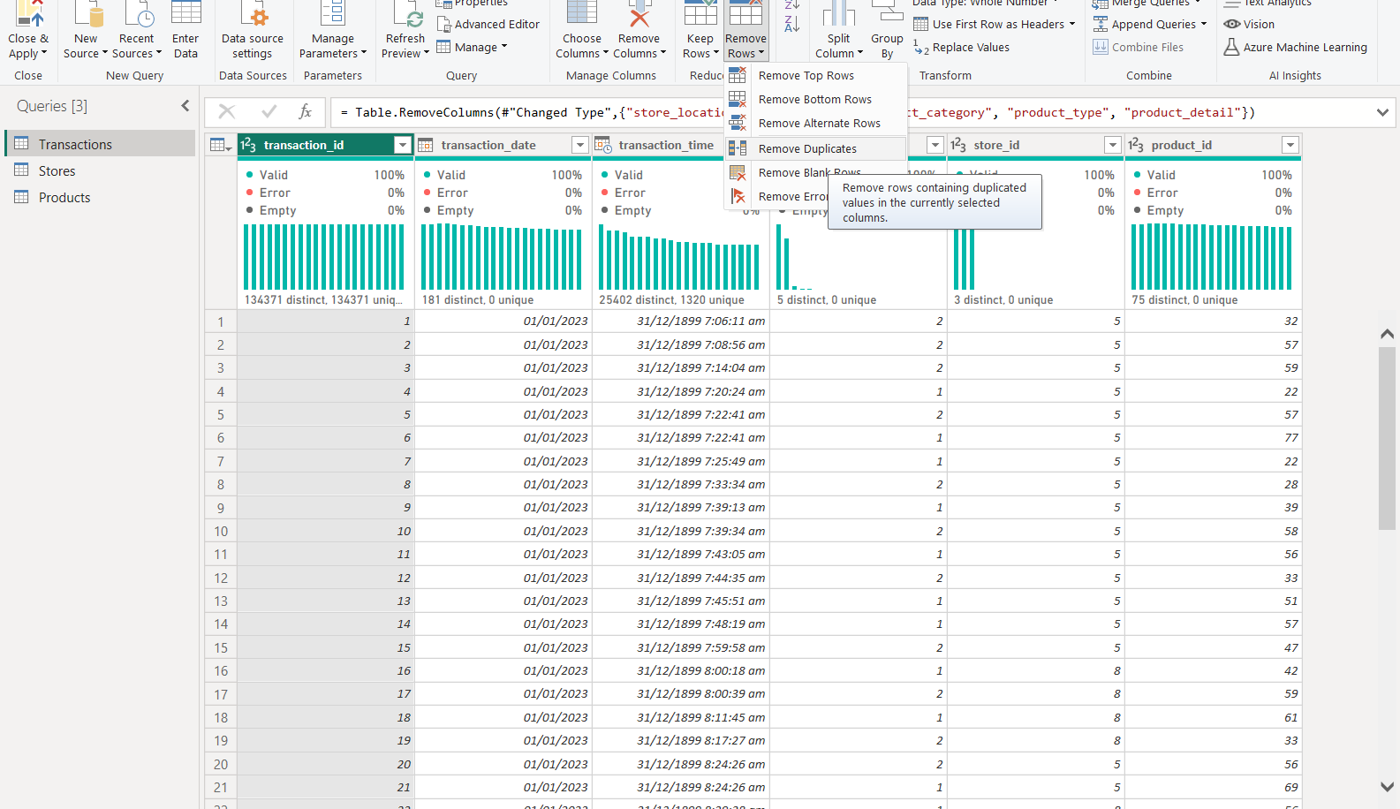

**Data Modeling**

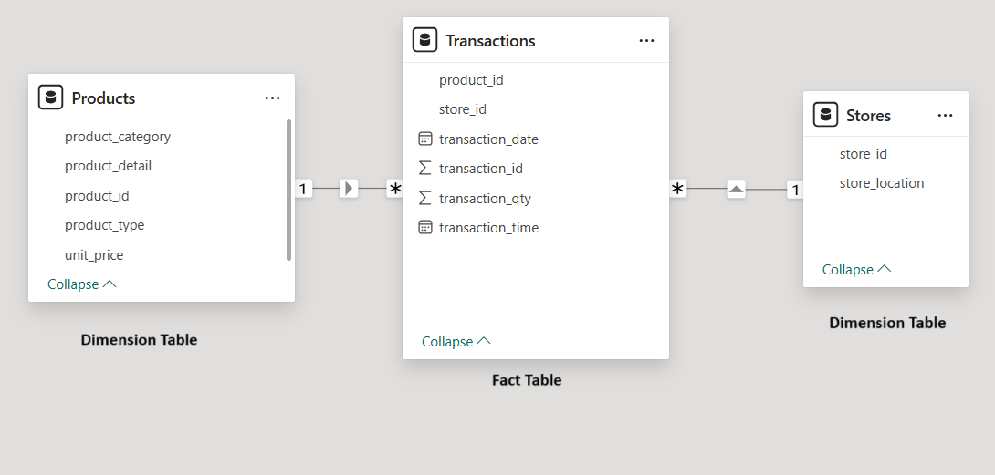

**● Identify Fact and Dimension Tables.**

**Fact Table:** Transactions

**Dimension Tables:** Products and Stores

**● Create Relationships between tables.**

**Products and Transactions:** One to Many

**Stores and Transactions:** One to Many

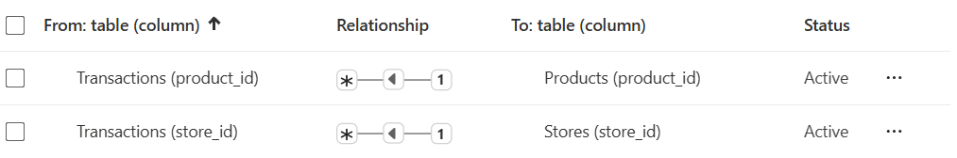

**● Identify the schema.**

This is **Star schema** as Fact Table: “Transactions” is directly connected to dimension tables: Products and Stores

**Power Query Analysis**

**Perform the following tasks:**

**1. Create a column for Sales**

**○ Merge column” Unit price” from “products” to the “Transaction” table.**

**Merging the tables on the basis of “product_id”:**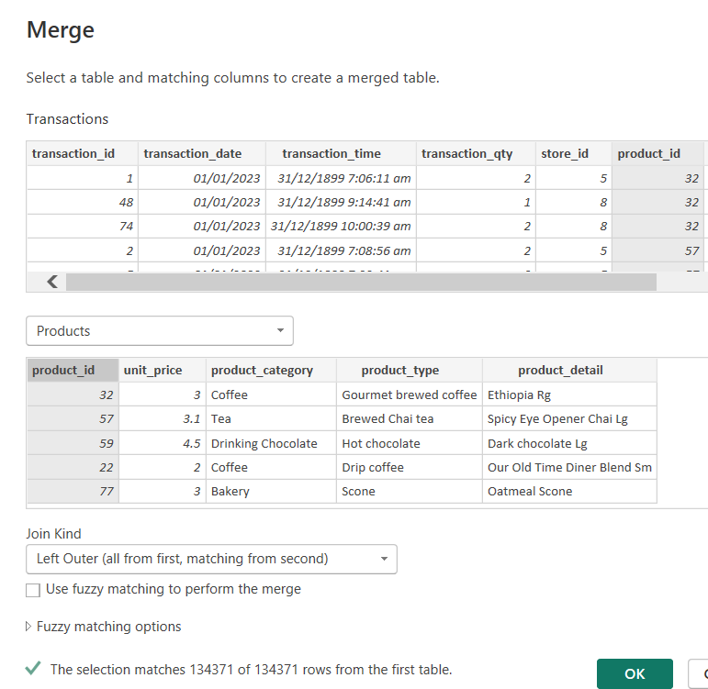

The “unit_price” column merged to the Transactions table: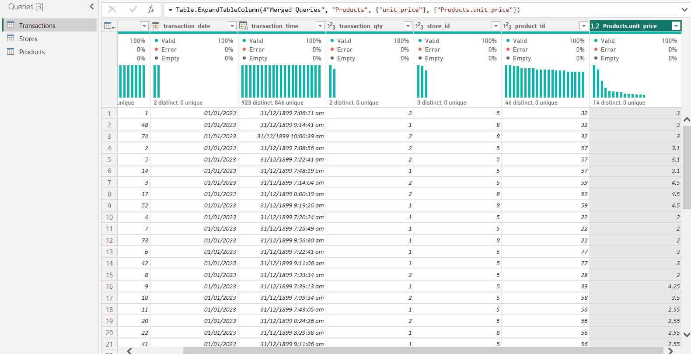

**○ Create a custom column: Sales = unit price x transaction_qty.**

**Creating a column using the formula:**

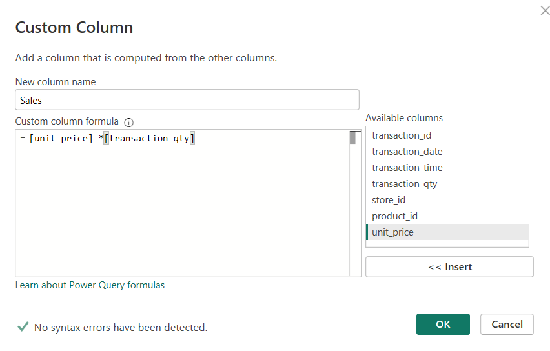

The “Sales” column is added to the Transactions Table:

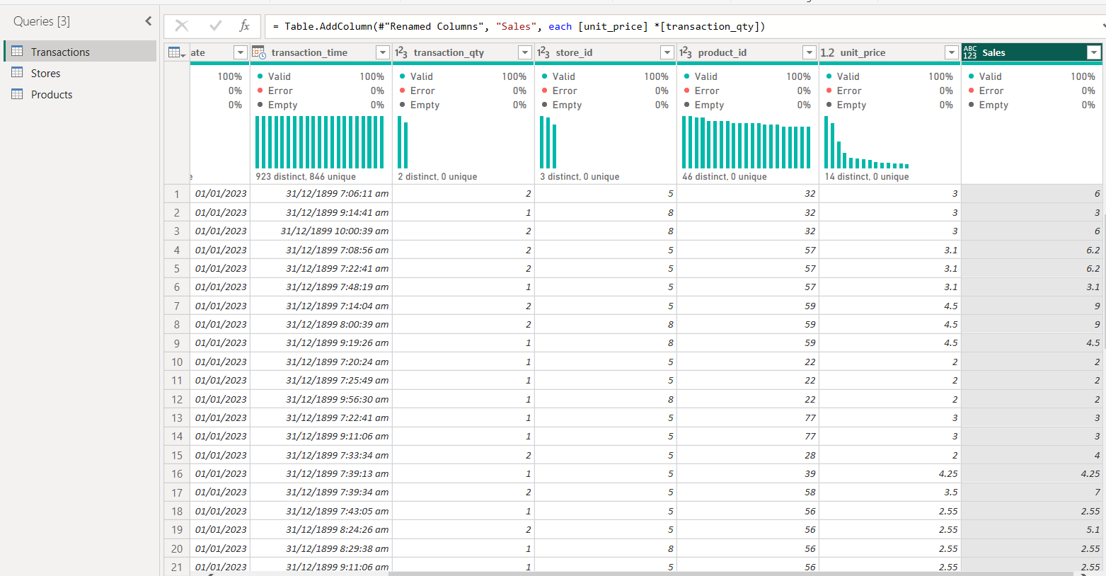

**2. Conditional column:**

○ Create a conditional column Is **High Quantity:**

If transaction_qty > 4, return **"Yes"**, otherwise **"No".**

**Adding conditional column:**

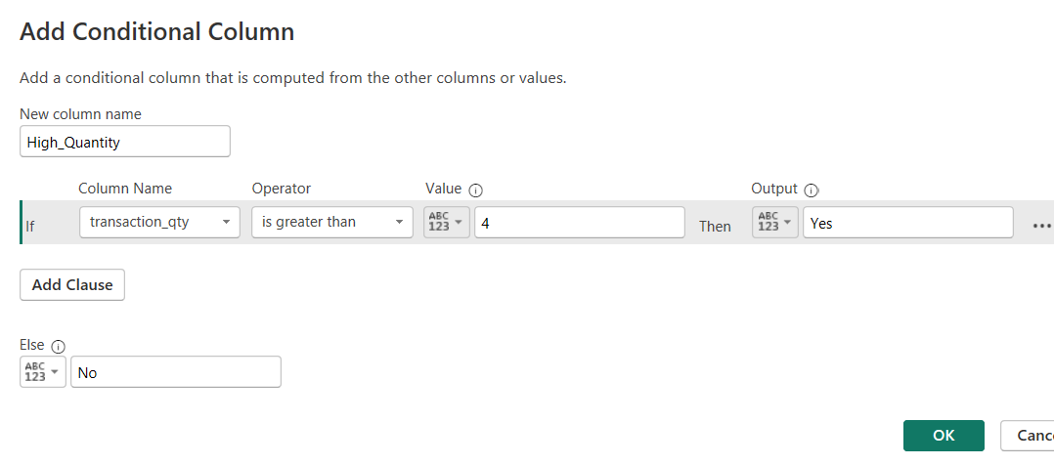

**Column High_Quantity added to table Transactions:**

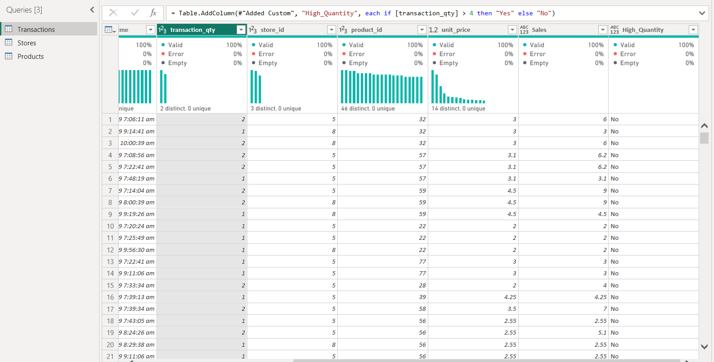

**3. Parameters:**

○ Calculate the given and store them as parameters:

i. Calculate **Total Sales:** Sum of Total Sales.

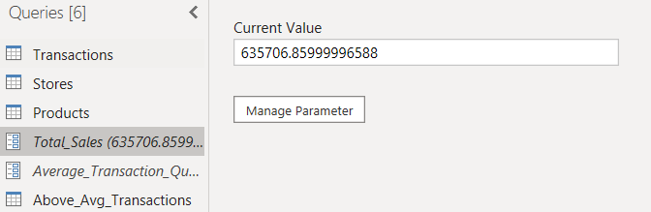

ii. Calculate **Average Transaction Quantity**: Average of transaction_qty.

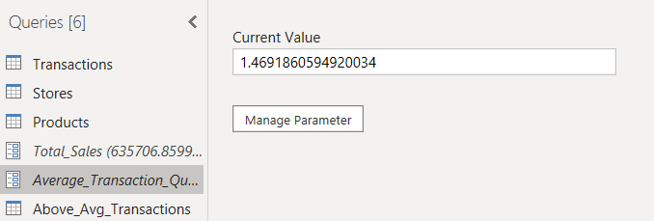

**4. Filter based on parameters:**

○ Create a duplicate of the Transactions Table.

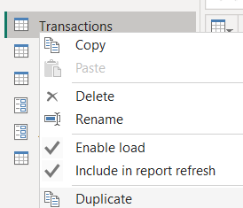

○ Filter the transactions with a quantity greater than the parameter “Average transaction quantity”.

Filter the rows having above average transaction quantity:

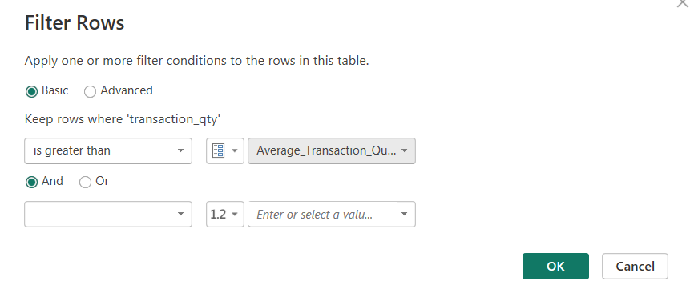

Above_Avg_Transactions:

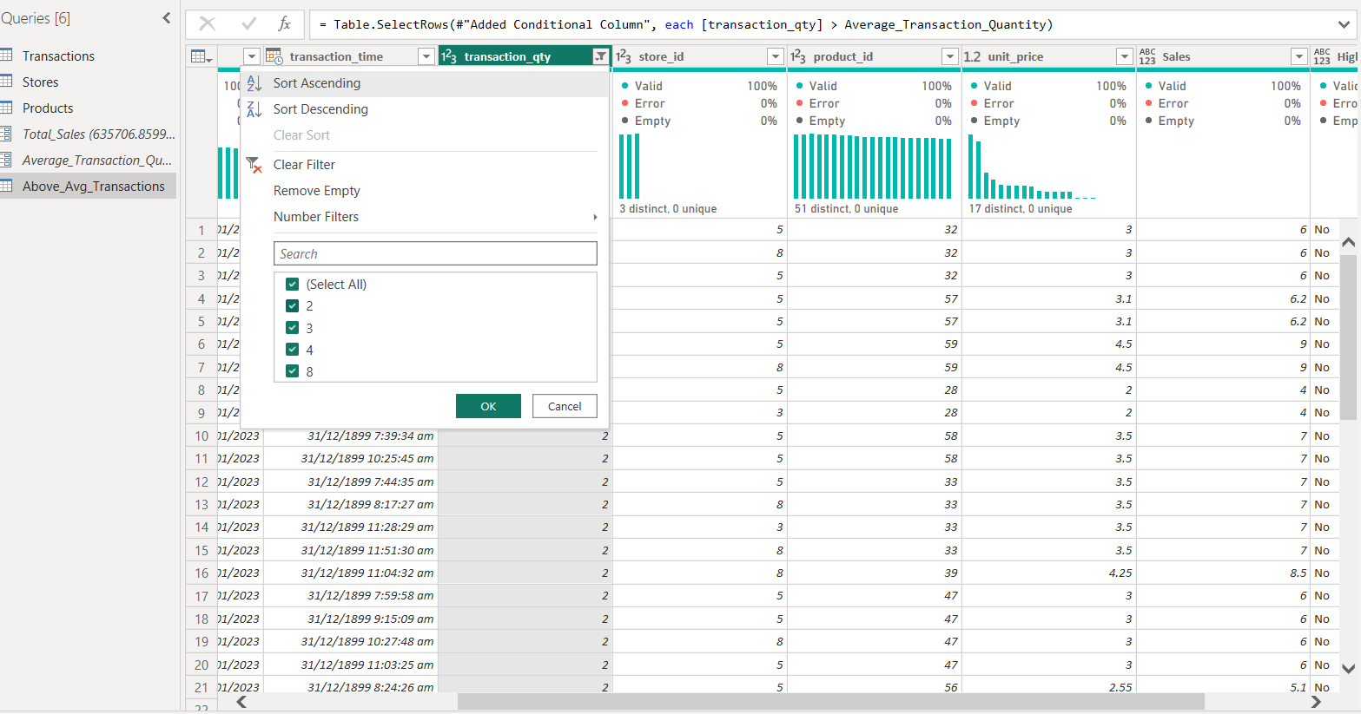

**5. Sales Based on Location:**

○ Merge Sales from “Transaction Table” to “Store” and show the aggregated value “Sum of Sales”.

**Merging the Sales column from Transaction Table to Store:**

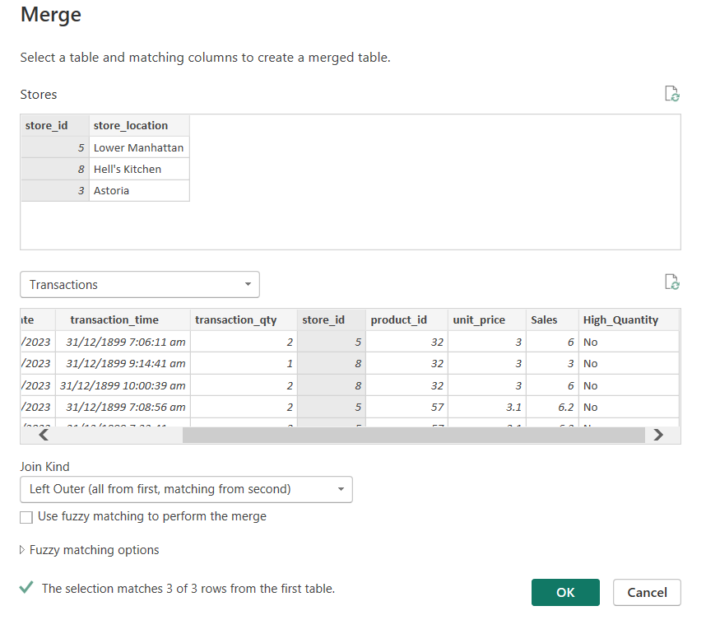

**Sales_based_on_Location:**

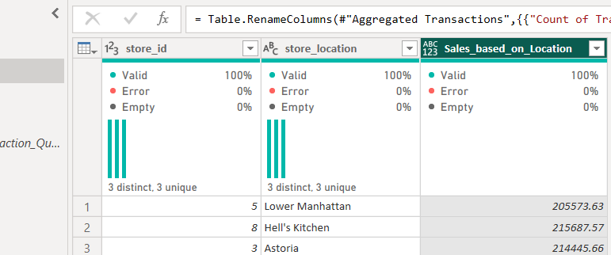

**6. Count of Products in each product Category:**

○ Create a duplicate of “Products”. Apply **GroupBY** to count products in each category. Rename this table as “Product summary”

**Duplicate the Products Table:**

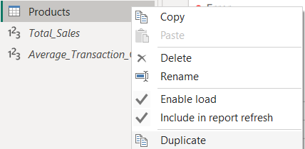

**Apply GroupBY to count products in each category**

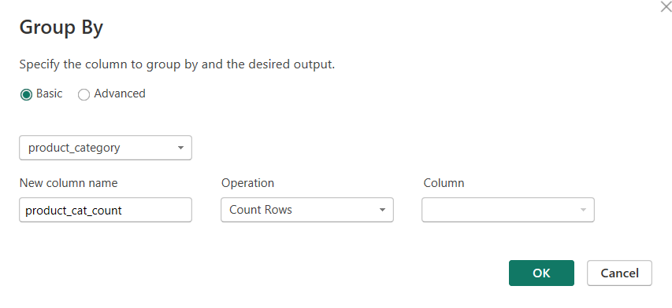

**Product count of each product category:**

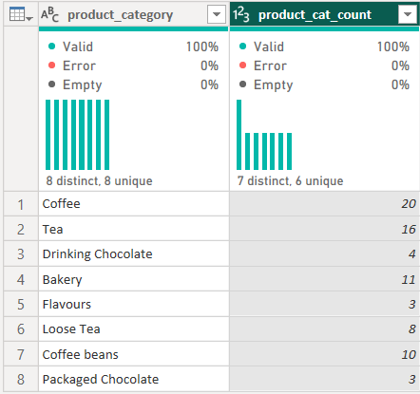

**Rename this table as “Product summary”**

